Ng Yit Tyn WID170035

**Results**

The performance of various agents for ***20 matches*** is as follow:

|  |  |  |
| --- | --- | --- |
| **Agent** | **Performance** | **Rank** |
| **ID_Improved** | 60.54 | 8 |
| **Student1** | 61.07 | 7 |
| **Student2** | 63.39 | 3 |
| **Student3** | 58.93 | 10 |
| **Student4** | 59.64 | 9 |
| **Student5** | 62.68 | 6 |
| **Student6** | 63.21 | 5 |
| **Student7** | 63.39 | 3 |
| **Defensive2Offensive** | 63.75 | 1 |
| **Offensive2Defensive** | 63.75 | 1 |

*Table 1*

The performance of various agents for ***20 matches*** is as follow:

|  |  |  |
| --- | --- | --- |
| **Agent** | **Performance** | **Rank** |
| **Defensive2Offensive** | 64.29 | 2 |
| **Offensive2Defensive** | 65 | 1 |

*Table 2*

In *table 1*, all the custom heuristics (**Defensive2Offensive** and **Offensive2Defensive**) perform better than ID_Improved and Student(s) by a reasonable margin as can be seen in above table.

**Offensive2Defensive** performs better than Defensive2offensive as can be seen in above *table 2*.

The raw evaluation result stated in *table 1* is stated below:

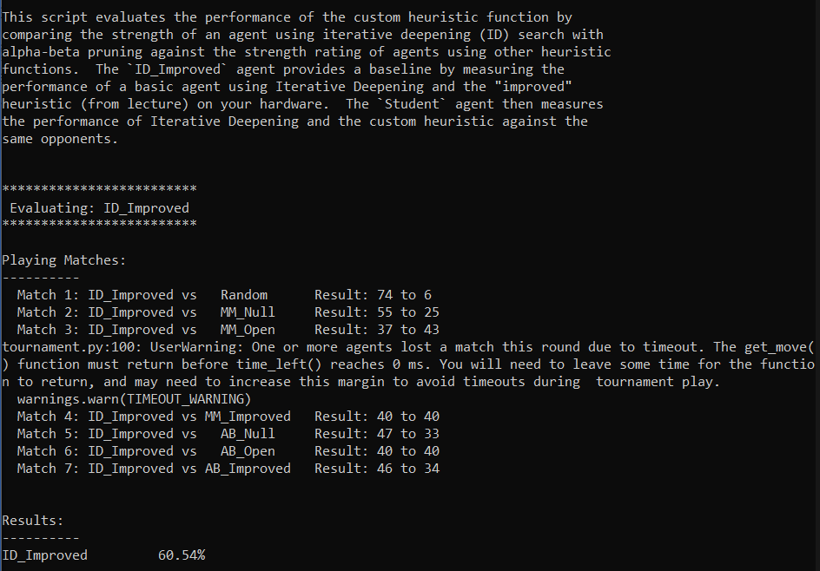

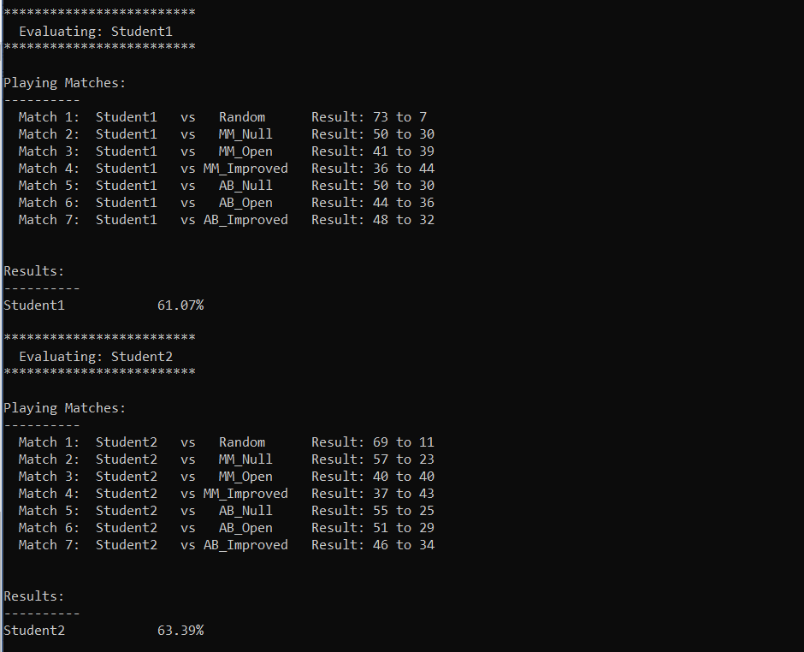

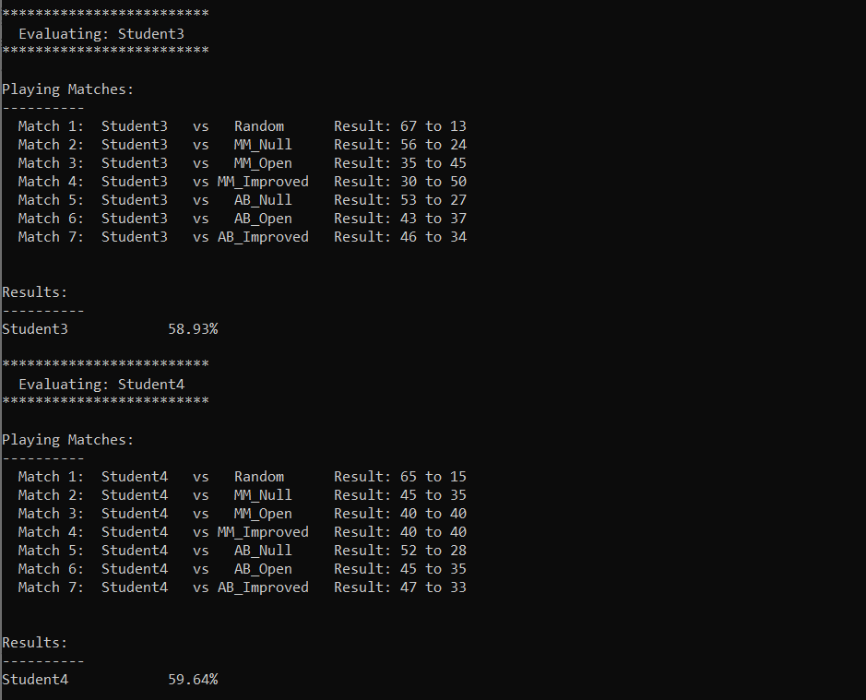

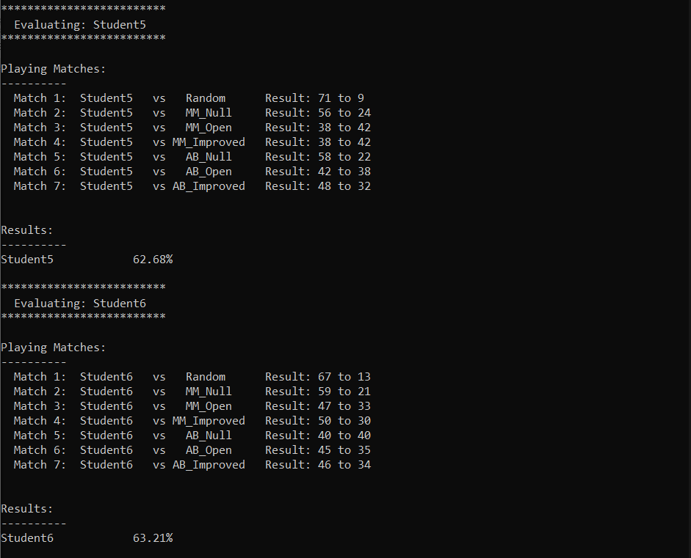

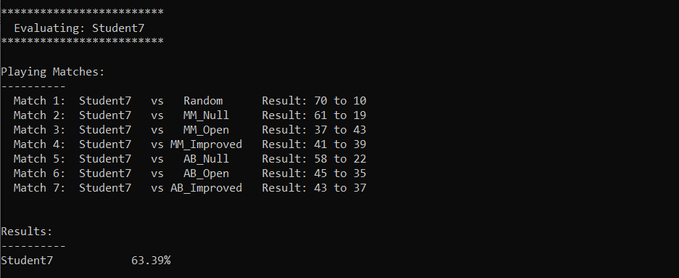

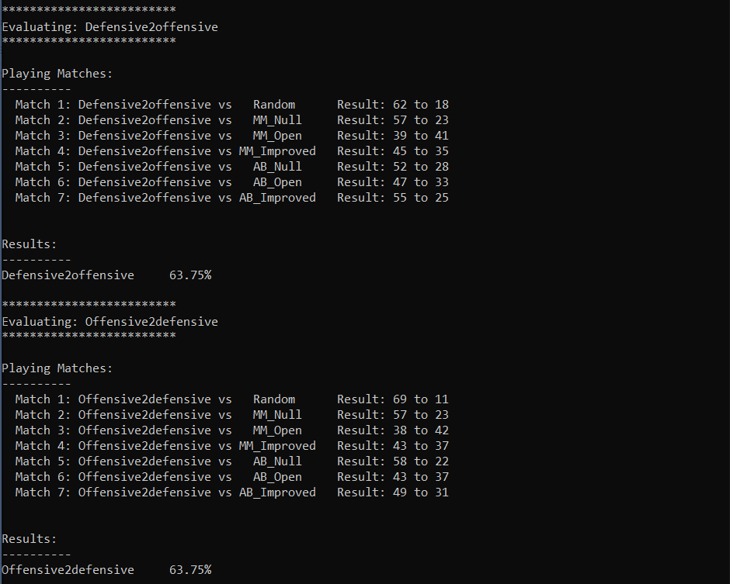

The raw evaluation result stated in *table 2* is stated below:

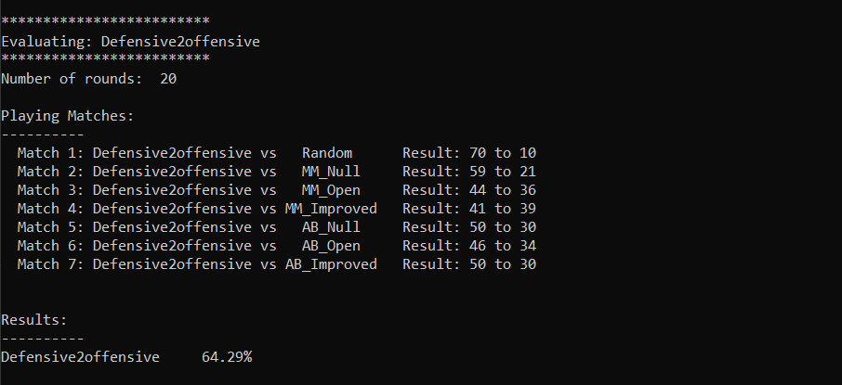

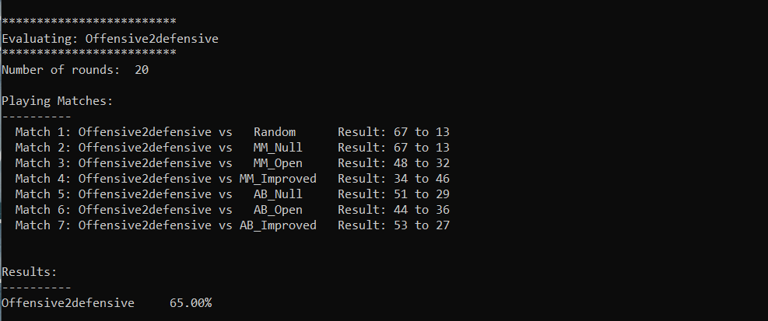

Conclusion: The custom_score function will implement to execute **Offensive2defensive** as it outperforms all other heuristics with win-rate **65%** which is the highest among all.